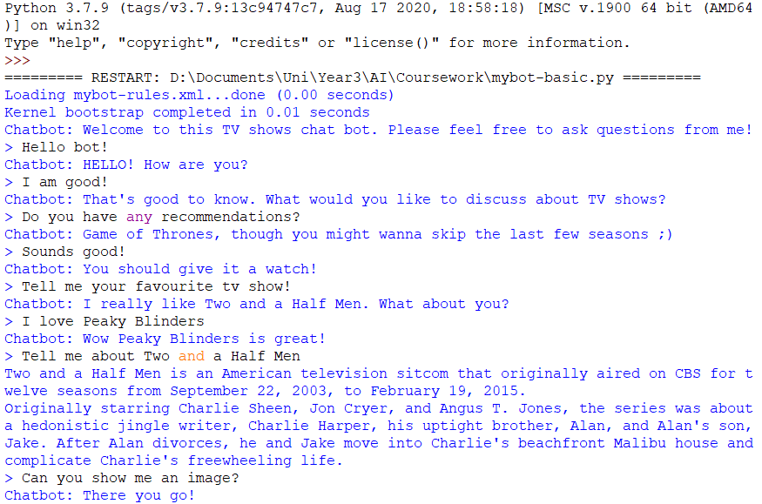

Rule based component using AIML rules and the RANDOM tag.



Rule based component using AIML rules and set tag.





Rule based component using AIML rules and then the python code handles the rule to utilise the Wikipedia API.

Rule based component using AIML. Python code handles the rule and plots the image using Matplotlib.

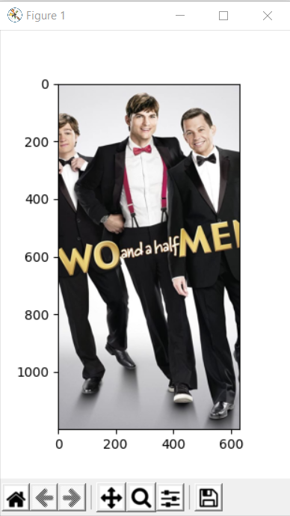

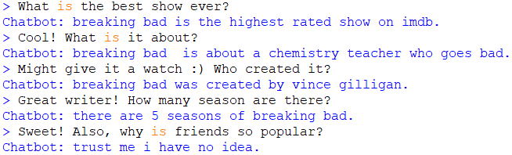

Rule based component using AIML rules.

Rule based component using AIML rules with RANDOM tag.

Rule based component using AIML rules with get tag.

Similarity based component using bag of words, tf-idf, and cosine similarity on data stored in csv file.